

FINAL CAPSTONE PROJECT REPORT

BREAST CANCER DETECTION SYSTEM

Submitted by:
Durgesh Kumar
MTech. Artificial Intelligence and Data Science Engineering
Enrollment Number: PA2503MTH467

TABLE OF CONTENTS
- Introduction
  - Purpose
  - Document Conventions
  - Intended Audience and Reading Suggestions
  - Scope
  - References
- Overall Description
  - Product perspective
  - Functions
  - Users
  - Operating Environment
  - Design and Implementation Constraints
  - User Documentation
- External Requirements
  - Hardware
  - Software
- System Features
  - Input
  - Prediction
  - Explainability
- Non-Functional Requirements
  - Accuracy
  - Speed
  - Robustness
  - Security
  - Usability
  - Scalability
  - Portability
- Assumptions and Dependencies
- Constraints
- Future Enhancements
- Risk Analysis
- Ethical Considerations
- Glossary
- Appendix A: Dataset Summary

- INTRODUCTION
The Breast Cancer Detection project will use custom CNN or any other image processing techniques to classify histopathology image patches as either cancerous (IDC present) or non-cancerous (IDC absent). Early identification of cancer plays a crucial role in improving patient health. The system processes an input image patch and generates a prediction along with a confidence score.
- Purpose: This Software Requirements Specification (SRS) defines the complete requirements for the Breast Cancer Detection System. It serves as a blueprint for developers, testers, supervisors, and end users to understand system behavior, constraints, design expectations, and evaluation criteria.
- Document Conventions
  - ML – Machine Learning
  - DL – Deep Learning
  - CNN – Convolutional Neural Network
  - IDC – Invasive Ductal Carcinoma
  - Shall – mandatory requirement
  - Should – recommended requirement
  - System –Breast Cancer Detection System
- Intended Audience and Reading Suggestions
  - Developers/Researchers – system implementation, model architecture, training and deployment details.
  - Project Supervisors – evaluate completeness, feasibility, and validation criteria.
  - Testers – validate predictions, UI behavior, and performance metrics.
  - Medical Students / End Users – high level understanding, limitations, and usage guidance.
- Scope: The product provides automatic detection of breast cancer using convolutional neural networks on histopathology patches. Key goals:
  - Detect presence of IDC in image patches.
  - Provide fast prediction with a probability/confidence score.
  - Offer an easy-to-use web interface for uploading images and viewing results.
  - Optionally produce interpretability heatmaps (Grad-CAM) to highlight suspicious regions.
  - Demonstrate application of DL for medical imaging assistance.
- References
  - Kaggle IDC Breast Cancer Histopathology Dataset
  - TensorFlow / PyTorch documentation
  - OpenCV, scikit-image image processing guides
  - Streamlit / Flask/Django framework documentation
  - IEEE SRS Standard (830-1998)
  - Research literature on histopathology image analysis and Grad-CAM

2. OVERALL DESCRIPTION
- Product Perspective
  - The system is a standalone web application composed of:
  - Frontend (Streamlit/Flask UI or Django)
  - Backend CNN model for inference
  - Image preprocessing pipeline (resize, normalize, augment during training)
  - Optional explainability module (Grad-CAM/heatmap)
  - Optional database for logging (not mandatory)
- Product Functions
  - Accept histopathology image patch as input (upload or drag-and-drop).
  - Preprocess the image (resize to model input size, normalize).
  - Extract features via CNN and perform classification (IDC vs Non-IDC).
  - Return prediction label and probability/confidence score.
  - Optionally generate Grad-CAM heatmap and overlay on original image.
  - Provide model information and usage guidance in UI.
- User Classes and Characteristics
  - Medical Students / Researchers: Familiar with pathology images and require clear metrics and explainability.
  - Developers: Implement training pipelines, model monitoring, and deployment.
  - General Users: Need simple UI, clear outputs, and disclaimers about clinical use.
- Operating Environment
  - Windows / Linux / macOS
  - Python 3.10+
  - Modern browsers: Chrome, Edge, Firefox
  - Libraries: TensorFlow or PyTorch, OpenCV, NumPy, Pandas
  - Streamlit or Flask/Django runtime for web UI
- Design and Implementation Constraints
  - Model performance depends on dataset quality and labeling.
  - GPU recommended for training; CPU sufficient for inference in many cases.
  - Initially supports only 50×50 patch images from the IDC dataset.
  - Only English documentation and UI text supported initially.
- User Documentation
  - README with installation and setup steps
  - Web UI quick-start guide
  - Model architecture and evaluation report
  - Optional tutorial video for end users and researchers

3. EXTERNAL REQUIREMENTS
- Hardware Requirements
  - Minimum:
• 12 GB RAM
• 12 GPU RAM
• 126 GB free storage
  - Recommended:
• 12–16 GB RAM
• NVIDIA GPU (for training)
• Intel Core i5/i7
- Software Requirements
  - Python 3.12.3
  - Deep learning framework: TensorFlow or PyTorch
  - Image processing: OpenCV, scikit-image
  - Utilities: NumPy, Pandas
  - Web UI: Django Framework
  - Matplotlib, Seaborn for visualization

Note: I have used Google Colab with TPU4, Below is the screenshot attached.
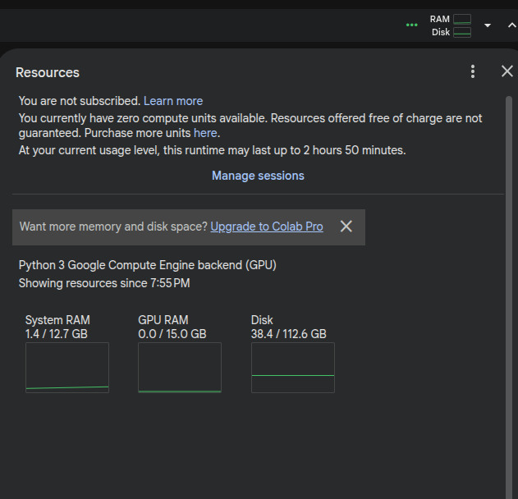
4. SYSTEM FEATURES
- Login/Signup
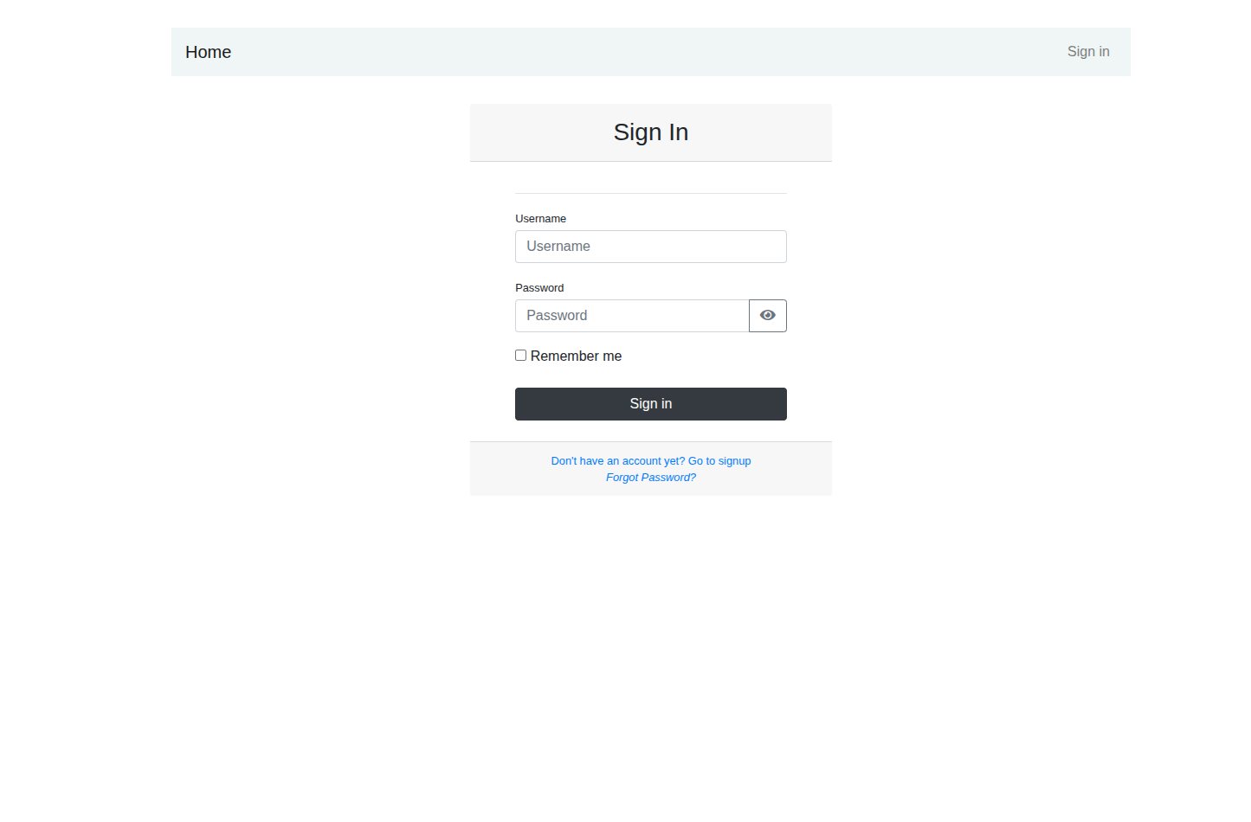
User can login to the System for Detecting Breast Cancer by uploading the patch image.
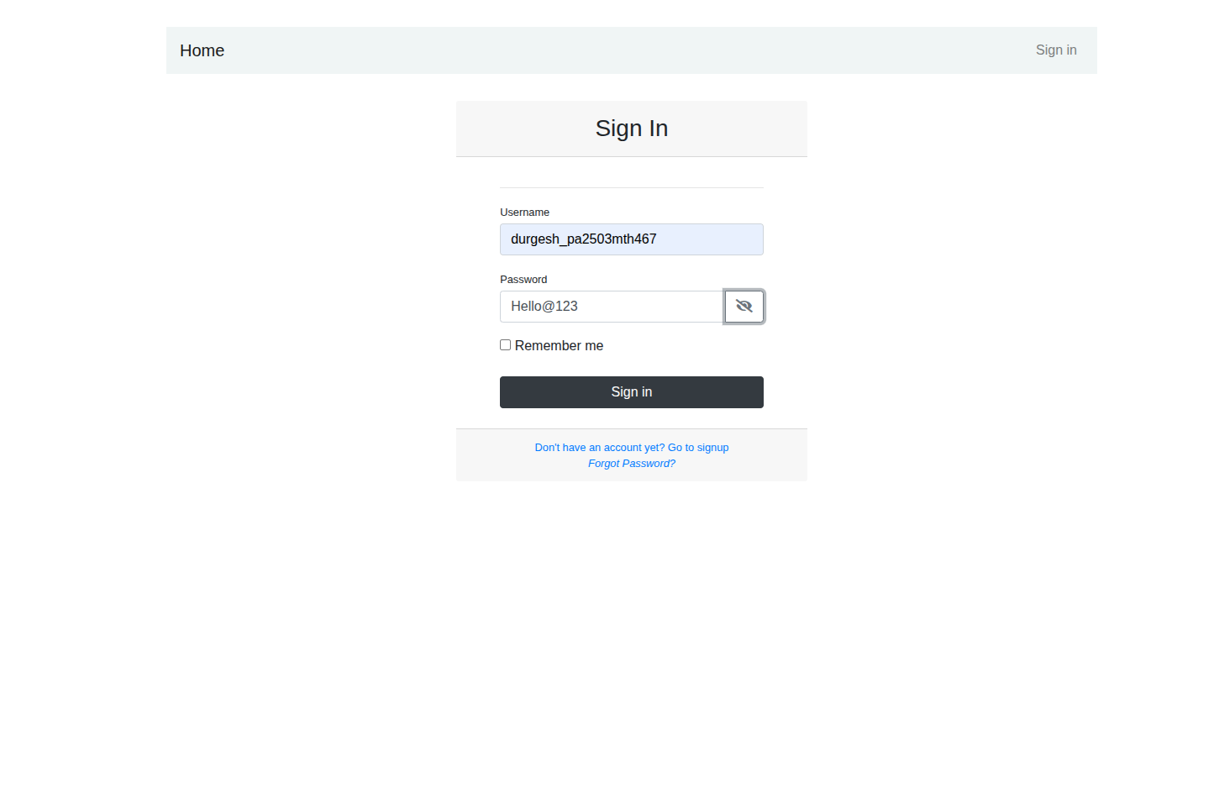
UserName : durgesh_pa2503mth467
Password: Hello@123
- Feature 1. Image Upload functionality
Description: Allows users to upload a histopathology image patch (PNG/JPEG) of fixed size.
Functional Requirements:
• FR1: Support PNG/JPG image formats.
• FR2: Validate that uploaded image dimensions and file size are within limits.
• FR3: Provide image name after upload.
• FR4: Reject corrupted or non-image files gracefully.
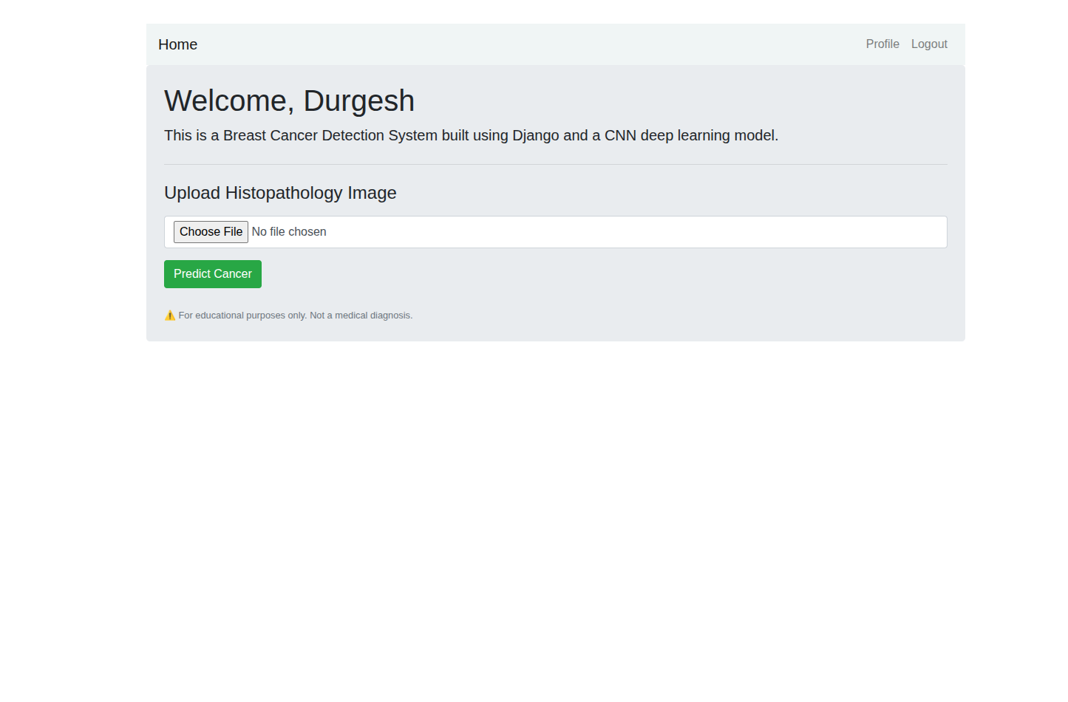
Feature 1: Image Select Functionality
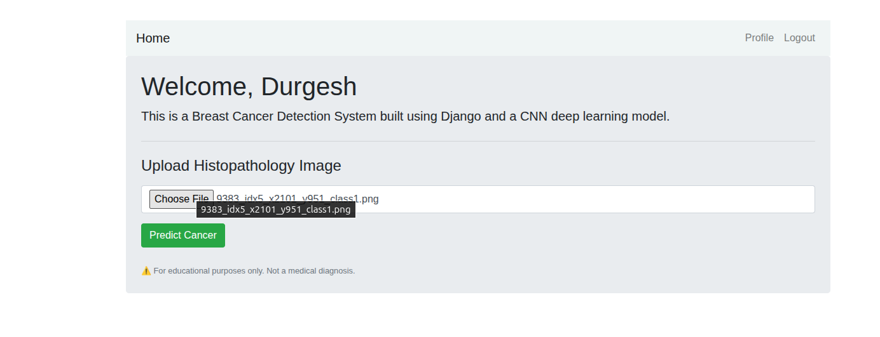
Image Upload Functionality

- Feature 2. Breast Cancer Prediction
Description: Classifies IDC vs Non-IDC using a trained CNN model.
Functional Requirements:
• FR5: Preprocess image (resize to model input size, normalize pixel values).
• FR6: Run inference in the backend model and output a label.
• FR7: Display probability/confidence score for the predicted label.
• FR8: Ensure prediction latency is < 1 second for standard inputs (on typical inference hardware).
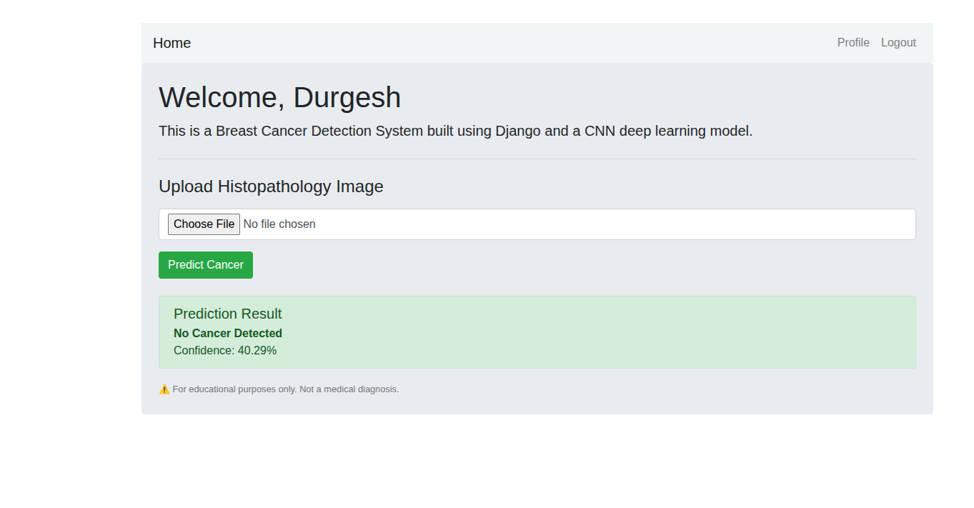
Prediction Result When No Cancer Detected
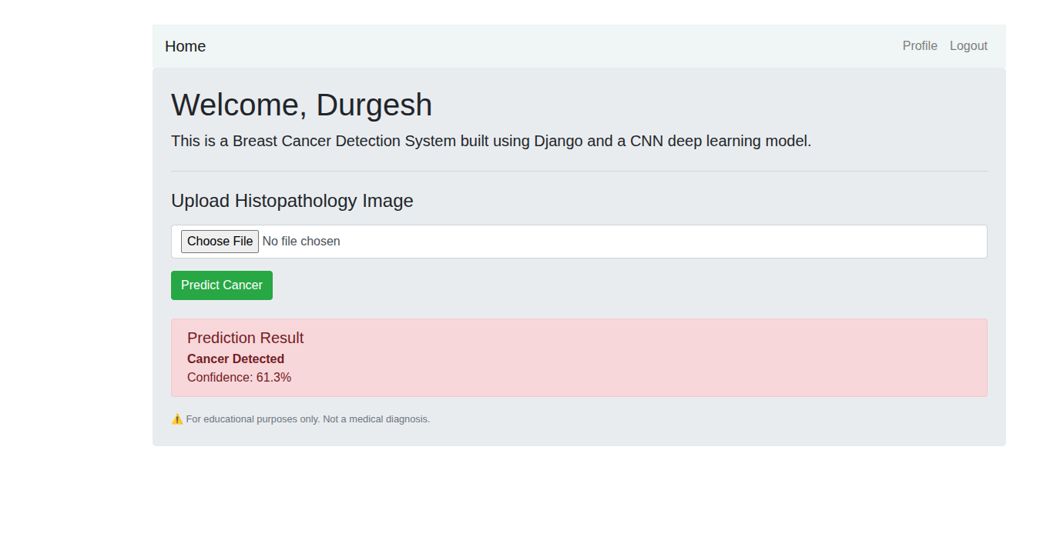
Prediction Result When Cancer is Detected

- Feature 3. Visual Explainability (Optional)

This is the model output. Its accuracy is more than 89%
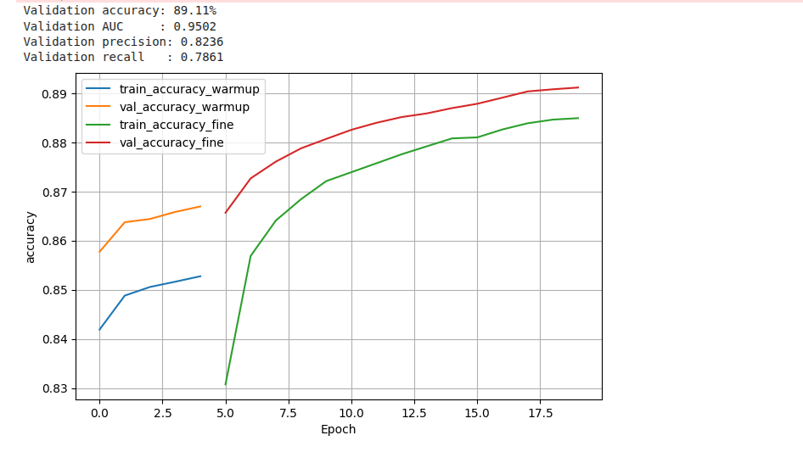
Accuracy vs Epoch Chart

Source Code Link for Training Model:
https://www.kaggle.com/code/durgeshrjkumar/breastcancerdetectioncapstoneproject
Source Code for Django Web App
https://github.com/durgeshrjkumar/BreastCancerDetection

5. NON-FUNCTIONAL REQUIREMENTS
- Accuracy
• Target overall model accuracy: ≥ 89% on held-out test data.
• Sensitivity (recall for positive IDC class): ≥ 85%.
• Specificity (true negative rate): ≥ 85%.
- Speed
• Prediction time: < 1 second (inference hardware dependent).
• UI load time: < 3 seconds.
- Robustness
• System shall handle noisy and slightly distorted images without crashing.
• Validation to prevent crashes on extremely large or malformed files.
- Security
• Input validation to prevent upload of malicious files.
• No persistent storage of user images by default (privacy-preserving).
• If logs are stored, personally identifiable information must be excluded.
- Usability
• Minimalistic, accessible UI with clear labels.
• Provide guidance and disclaimers about clinical usage.
• Mobile-responsive layout for small screens.
- Scalability
• System design supports swapping in larger models or deploying on cloud infrastructure.
• Support for batch inference and API endpoints for integration.
- Portability
• The application shall run on Windows, Linux, and macOS. It shall be accessible via modern browsers.

6. ASSUMPTIONS AND DEPENDENCIES
- Assumptions
  - Users will provide image patches similar to the IDC dataset (50×50 px patches).
  - Training dataset labels are accurate and representative of real-world cases.
  - Users have access to modern web browsers and basic internet for cloud deployments.
  - Model updates and retraining will be performed periodically to maintain performance.
- Dependencies
  - Availability of the Kaggle IDC dataset for training and validation.
  - Deep learning libraries (TensorFlow / PyTorch) and image processing libraries.
  - Hardware resources for training (GPU recommended).
  - Optional cloud services for deployment (AWS/GCP/Azure).

Note: Dataset URL
https://www.kaggle.com/datasets/paultimothymooney/breast-histopathology-images

7. CONSTRAINTS
- System supports only image (patch) input initially; no whole-slide image (WSI) support in v1.
- Model performance limited by dataset representativeness and labeling quality.
- Transformer or very large models may require substantial compute resources.
- No integration with clinical hospital systems in initial release (out of scope).

8. FUTURE ENHANCEMENTS
- Support for whole-slide image analysis (WSI) and tiling pipelines.
- Multi-class tumor grading (e.g., tumor grade or subtype classification).
- Mobile application for image capture and on-device inference.
- Integration with hospital information systems and PACS.
- Automated retraining pipelines and model monitoring in production.

9. RISK ANALYSIS
- Technical Risks
  - Model overfitting due to limited diversity in training data.
  - Mismatch between dataset patches and real clinical samples.
  - Dependency/version conflicts across libraries (TensorFlow/PyTorch).
- Operational Risks
  - Users uploading non-medical or corrupted images causing errors.
  - Performance degradation if run on low-spec hardware without acceleration.
- User Risks
  - Over-reliance on AI predictions; users may treat results as definitive diagnosis.
  - Potential legal/ethical implications if used in a clinical setting without approval.

10. ETHICAL CONSIDERATIONS
- Provide clear disclaimers that the tool is an assistive system and not a substitute for clinical diagnosis.
- Ensure no patient-identifiable information is included in datasets or logs.
- Avoid biases by auditing dataset composition and model behavior.
- Maintain transparency on model limitations and expected performance.
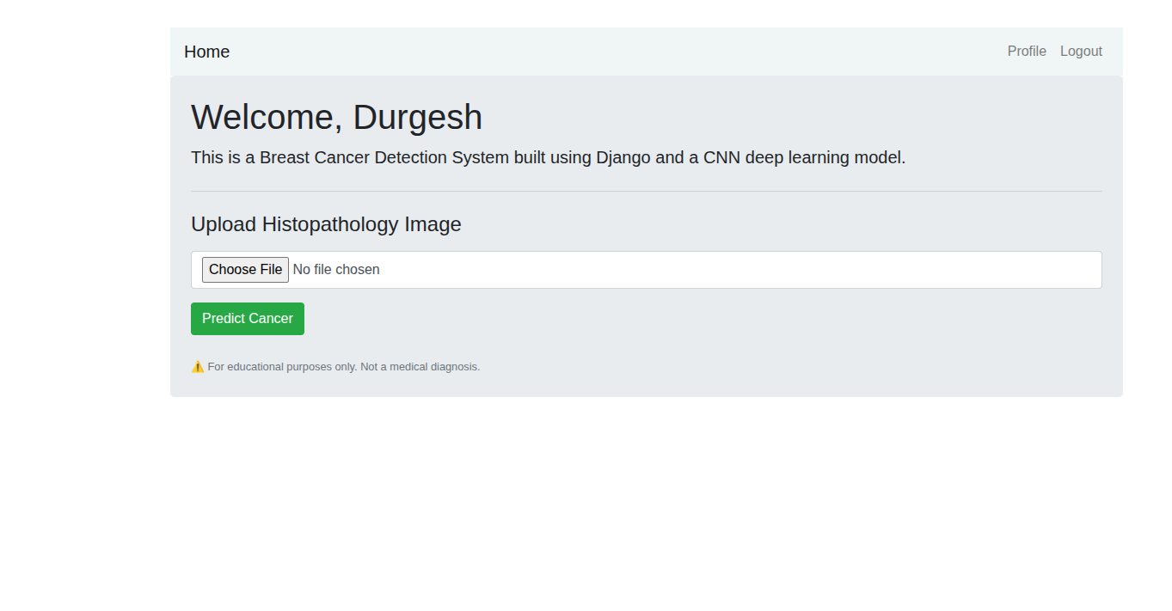

Note: No patient information is stored and Disclaimer has been put that this system is for educational purpose only.
11. GLOSSARY
TERM
DEFINITION
IDC
Invasive Ductal Carcinoma
CNN
Convolutional Neural Network used for image classification
Grad-CAM
Gradient-weighted Class Activation Mapping, used for visual explainability
Patch Image
Small cropped region from a histopathology slide (50×50 px)
Precision
Ratio of true positives among predicted positives
Recall (Sensitivity)
Ratio of true positives detected among actual positives

12. APPENDIX A: DATASET SUMMARY
- Dataset Information
• Source: Kaggle IDC Breast Cancer Histopathology Dataset
• Number of image patches: ~277,524 (varies by dataset release)
• Patch size: 50 × 50 pixels (RGB)
• Classes: 1 → IDC (cancer), 0 → Non-IDC (normal tissue)

- Preprocessing Steps
• Load images and match labels from dataset metadata.
• Remove or flag corrupted files and missing labels.
• Resize/verify images to model input size and normalize pixel values.
• Data augmentation for training: flips, rotations, color jitter, zoom.
• Split dataset into training, validation, and test sets (recommendation: 70/15/15 or stratified splits).
- Handling Imbalance
• Use augmentation to expand minority class (if imbalance exists).
• Apply class weights or weighted loss functions during training.
• Consider oversampling/undersampling strategies or focal loss for highly skewed distributions.
• Use stratified splits to maintain class balance across train/val/test sets.

13. MODEL ARCHITECTURE & EVALUATION (SUGGESTED)
Suggested CNN architecture (example):
- Input: 50×50×3 RGB patch
- Conv Block 1: Conv2D -> ReLU -> BatchNorm -> MaxPool
- Conv Block 2: Conv2D -> ReLU -> BatchNorm -> MaxPool
- Flatten -> Dense -> Dropout -> Output (Sigmoid)

Training & Evaluation Guidelines:
- Use binary cross-entropy loss with appropriate class weights.
- Monitor metrics: accuracy, precision, recall, F1-score, AUC-ROC.
- Early stopping on validation loss, use model checkpoints.
- Perform k-fold cross validation if dataset permits.

